RECKON ACCOUNTS HOSTED EXCEL REPORTING

When I export a job costing to excel, under the new XLSX format, then download it, the format of the blank cells is Text rather than number. This is annoying when needing to add more numbers such as markup's or additional costs not in the accounts. It means I have another step to highlight all the blank cells where I think there might need to be a number and reformat to number.
I never had this issue in the old format of xls.
Any suggestions?

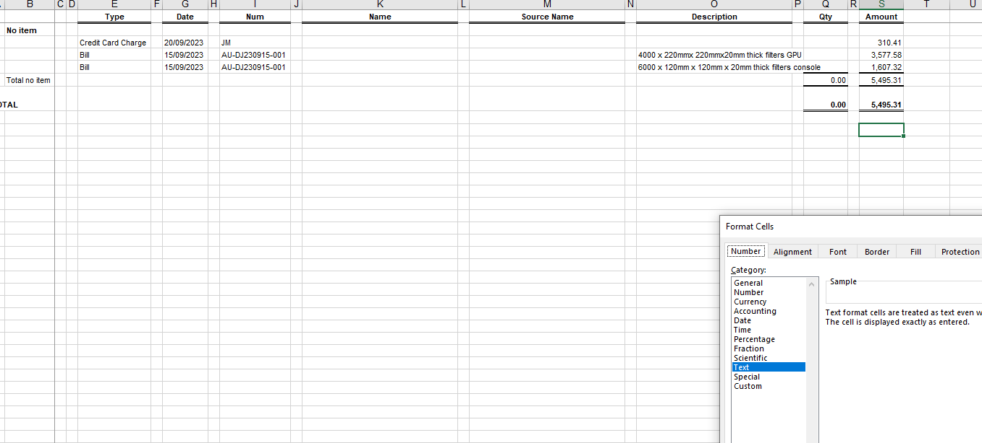
This appears to happen for the columns that have numbers in it. I can input numbers but if I input a formula the formula is typed and a conversion to number has to be made.
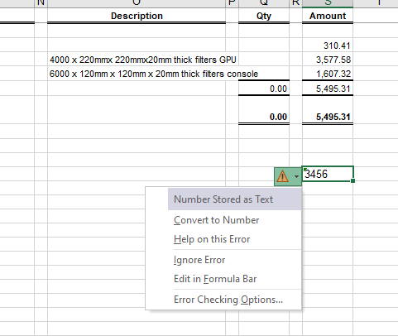

For the columns adjacent to data the cells have General formatting
